3.4 AMPERE

The Ampere shows basically the magnetic field on Earth, resulting in a field aligned current density, and this field is measured by satellites, where in the plot, for instance, if the field vectors point in a certain direction, the tail refers to the satellite position.
For the current density, choosing the North pole, we can see an pattern where the currents encircle the pole, and its intensity are represented by intensity in the color, and the two different colors represent the direction of these currents, where:

Red – Upward currents;
Blue – Downward currents.

These field-aligned currents are called Birkeland currents, and should follow a certain pattern, where at the dawn, and poleward, must be down into the ionosphere, and upwards at the dusk. Now we must analyze for each time interval the behaviour of these fields and currents, and for each one hour, we plot values which will help us to see when the aurora starts to happen with respect to these parameters.

1800-1900: Between 1800-1810, occurs the highest magnetic activity in this period, after that, the current density is narrow, and no significant phenomena for our case is suggested.
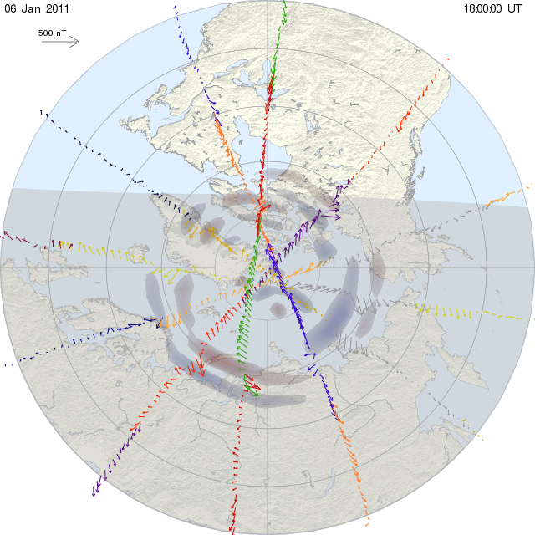
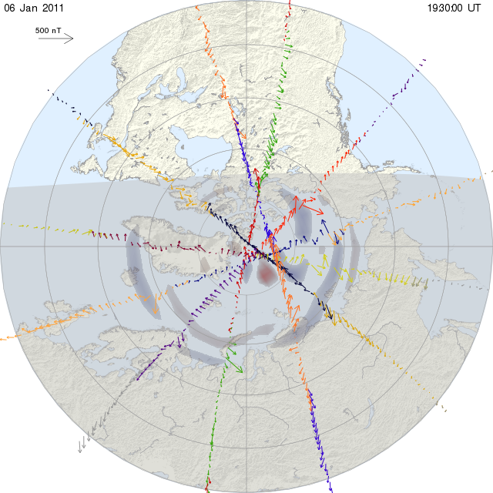

1900-2000: The current density remains narrow with a short increase at 1930, but nothing more. These results agree with the IMF data, where we see no interaction in this period, and what we expect is that after 2000, the pattern will change.

2000-2100: Around 2010, and also 2050, B gets slightly more intense, so as the current density, but just at 2100, there is a significant increase in activity, comparing to previous times.

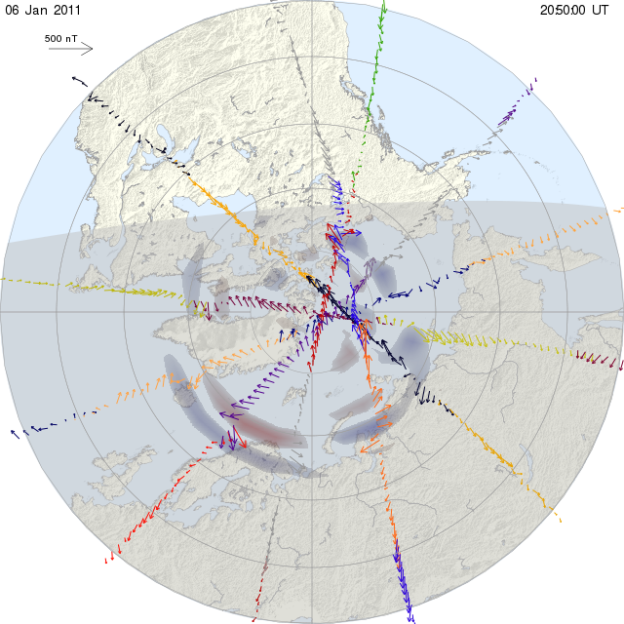
2100-2200: The slight increase at 2100 of the current density gets bigger 10 min after, but in the interval 2120-2140, decreases again. But, at 2150, the current density suddenly gets bigger considerably.

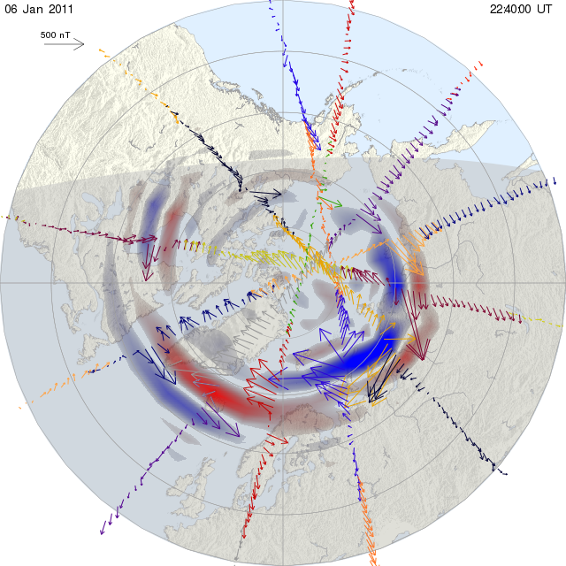
According to data from ACE, the solar wind arrives at Earth, at between 2113-2117, and from this time on, magnetic reconnection can happen at magnetopause. This time is basically when the Bz-component of the incoming solar wind is negative, necessary condition for reconnection. All-sky Camera suggests that the auroral activity starts around 2220, so magnetic reconnection has already happened, so we must look again to the data between 2150 and 2220 on the current density plot.
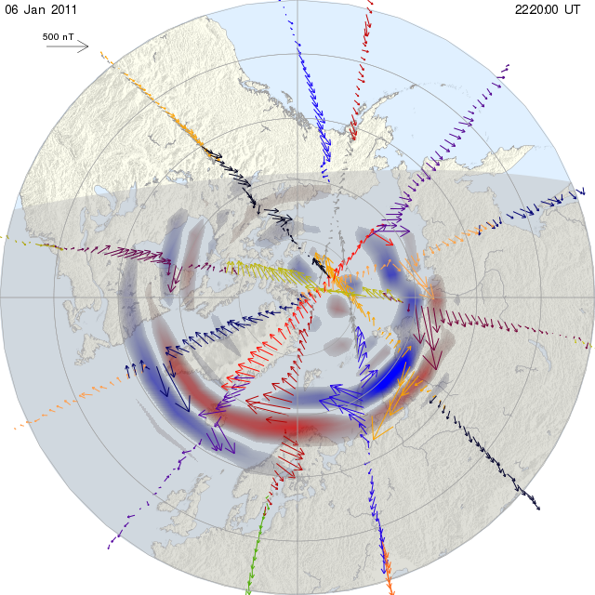

2200-2300: This increase continues approximately linear until 2210, where the current density becomes intense, mostly around the area of Greenland, Norway and Russia. At 2250, the currents become more distributed.

2300-2400: The magnetic activity becomes highly intense from now on, with the current well distributed, around the North pole, and so the B vectors have their peak of magnitude, especially from, 2320 and, this happens also in the Svalbard area, where the other data we are analyzing comes from.
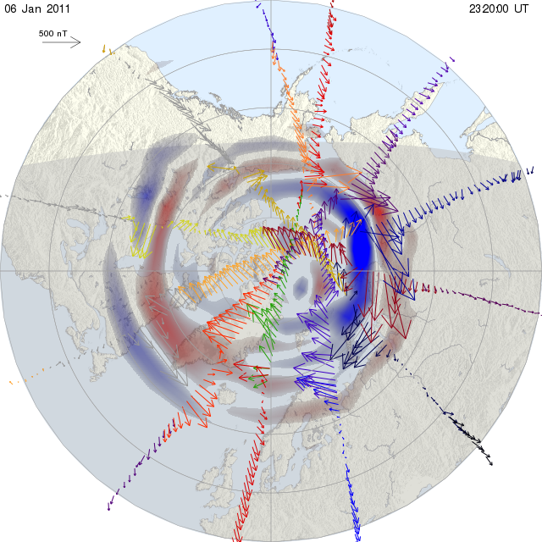
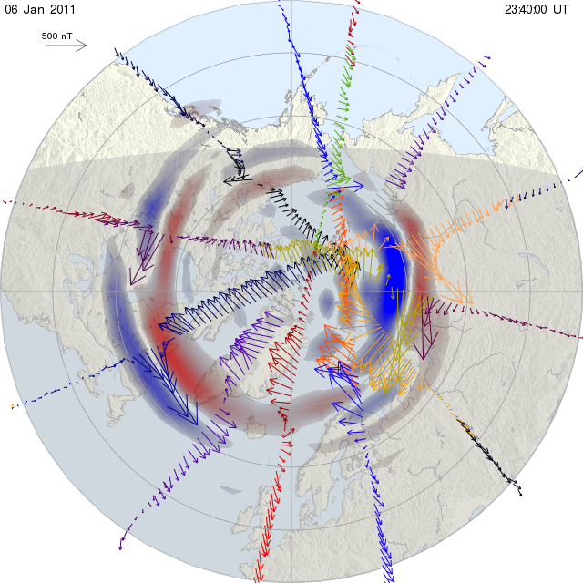

3.5 Ground-Based Magnetometers

Looking at the z-component of B, it it possible to check the field in the Earth. On the plot for Ny Ålesund station, represented by NAL, we choose the time interval 1800-2400, Svalbard area, scale value «automatic» for the instrument scale in the right order of B value, and a 10s averaging value.
The z-component remains approximately constant from 1800 until 2210, where magnetic activity starts to increase, and a sudden even bigger increase around 2240, peaking at 2300, with just a local minimum at 2330 and increasing again to basically the same point in a short period of time, until 2400. Looking now on the plot in more detail, lets see hat happens in each hour, in the mentioned interval:

Between 1800 and 1900, the field oscillates on maximum values of 10nT, and keeping approximately constant value for few minutes, which is not enough to have reconnection, if the IMF is present.

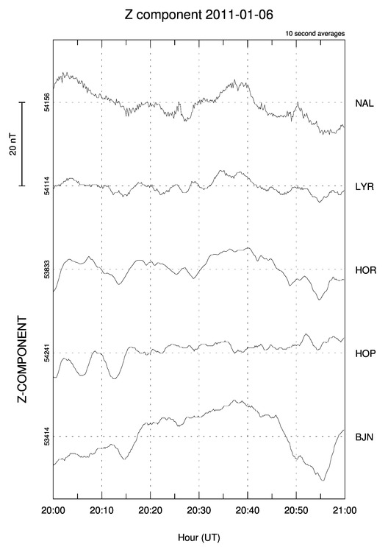
Between 1900-2000, there is more oscillation in the field, but at even smaller values, where we can see that the scale gets smaller, from 20nT to 10nT.
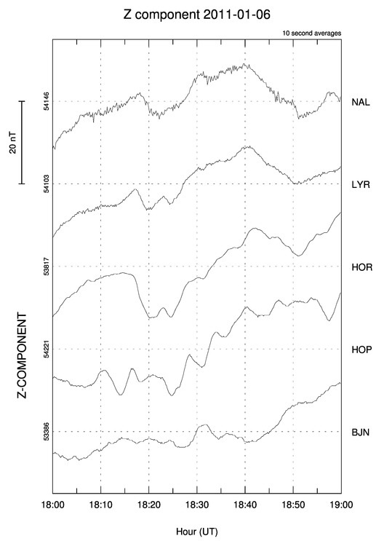
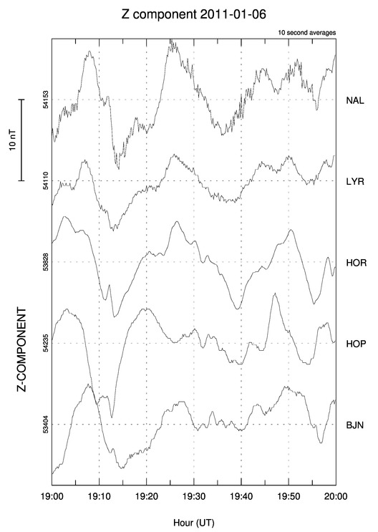
From 2000 to 2100, the behaviour is quite similar to the first interval, but with low peaks of magnitude. However, in this time interval, we calculated that around 2010, the solar wind IMF hits the ACE satellite, and in about one hour, it will interact with the magnetopause, so we should expect some activity in the next hour.

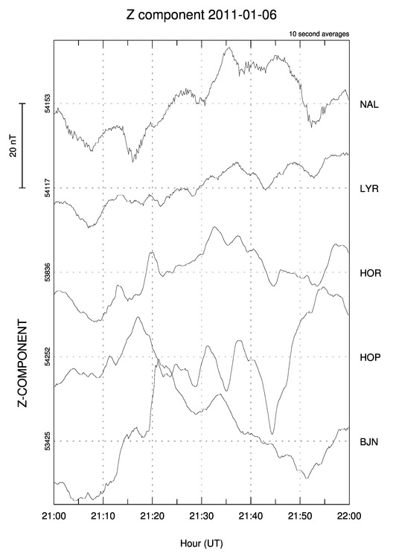
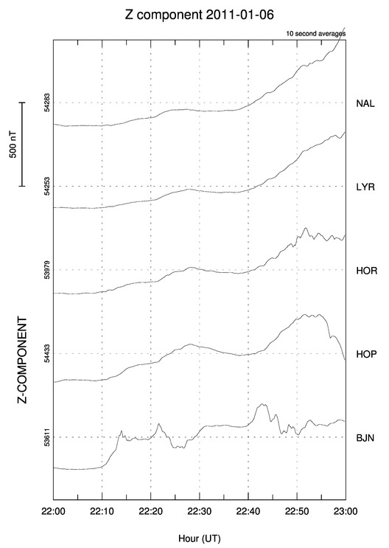
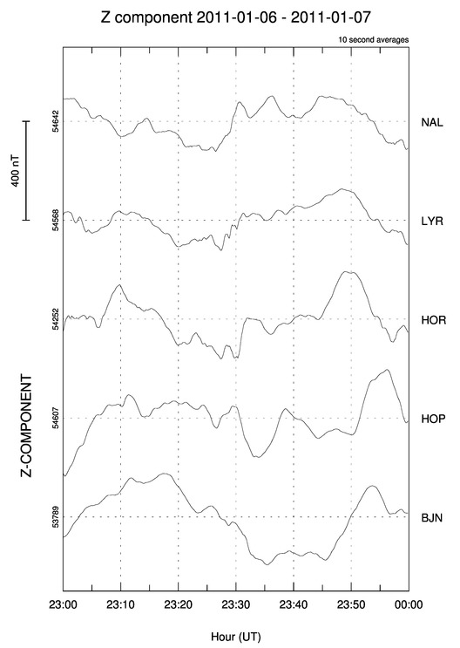

Now we have more magnetic activity, and for more time, especially in the interval between 2135-2145. But as we can see from the All-sky Camera and because of the decrease in magnitude after this period, magnetic reconnection it is still not possible. But looking at the time that the field value starts to increase, apparently agrees with the computation of time using ACE, where in the plot, around 2117, the field increases (almost) continuosly.

This happens probably at the next time interval, where we first see that the scale has changed to 500nT, much more than the previous measurements, and increases around 100nT in few minutes as it is possible to see in the first minutes. The All-Sky shows that the aurora starts at 2220, and looking at the plot, from this time to 2240, the field has its most constant value, before increase suddenly in the last 20 minutes.

In the last time interval, we see a distribution like the very first plot, where the field oscillates between local maximum and minimum, but this time at a very higher scale, of 400nT, so even with this oscillation, the field has a high value all the time from 2300 to 2400, and consequently, magnetic reconnection has already happened and we have also and intense aurora, as shown more explicitally by the All-Sky.

3.3 SuperDARN

To plot the measurement of the plasma convection in the F-region, and study its velocity and other features that will appear which will be more aparent as the magnetic reconnection happens, we first set the instrument to the Pykkvibaer, located in Iceland and it is directed to the Svalbard area.

First, we look at the polar cap in the interval 1758-1800. The convection area comprises a relatively small area in the polar cap, and the velocities indicated by the vectors, with different colors according to magnitude, and also showing the diection, shows that the average velocity is around 375 m/s, which is basically the same velocity as the solar wind at the same time.

But now it is important to interpret what we see here. The Earths magnetic field causes the plasma that is settled to flow as a current in a pattern that can be seen from the coloured arrows. Based on these currents, the plot also shows the field potentials, and the equipotential lines with value (fi) measured in kV:

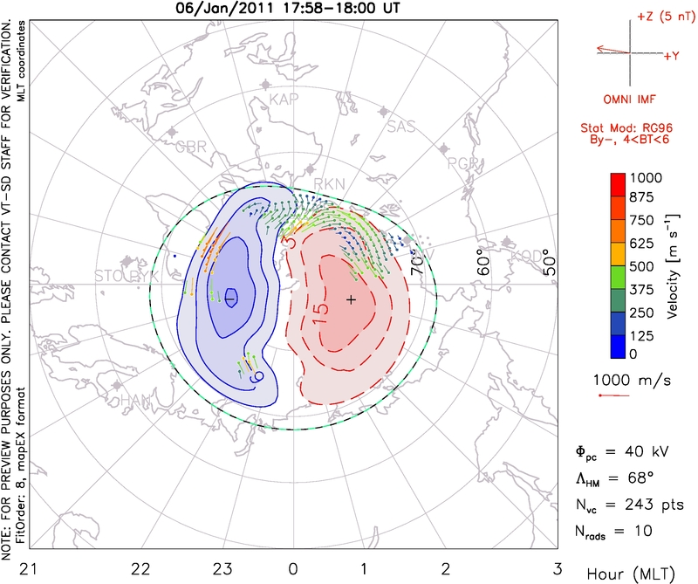
The trajectory of the plasma flow can be observed by the arrows, and its possible to have idea abou the velocities. The amount of lines in just one region is because of area coverage of the instrument.

The aspects we will notice from now on, and try to relate to magnetic reconnection and help to investigate the auroral activity, are the size of the polar cap, the velocity of the plasma flow and the pattern of the equipotential lines. In this case the polar cap size is small as well as the velocities, where the vectors appear as green and blue. This suggests that reconnection has not happened yet. The potential value is the expected for quiet times, where the average is about 50kV ([1] pg.:303)

If we run the plot one hour later, from the other measurements, its expected to have the minimum of magnetic activity around this time, so (fi) must be lower than before, as well as the polar cap size, that if not smaller, it will not change considerably. So as the velocity, that might be the same or lower at most regions. This way, we cannot expect magnetic reconnection:

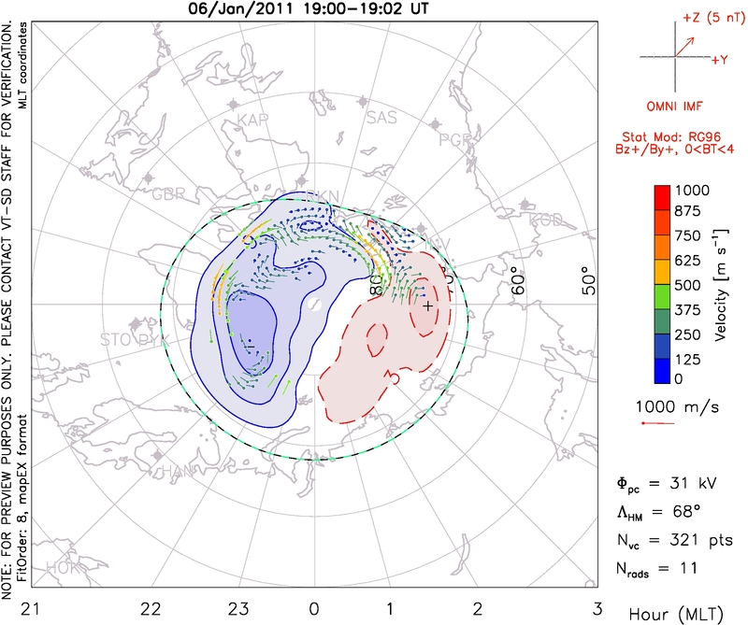
(fi) is just 31kV, as expected, and also the velocity is lower, with green and blue arrows dominating (between 250 m/s and few lines around 500 m/s), the distribution of the equipotential lines changed considerably, but it is also expected from «quiet times».

For the next hour, it was predicted that the solar wind and its IMF would interact with the ACE satellite and in about one hour will interact with the magnetopause and from this time on, magnetic reconnection is possible. So, for this next hour, it is expected basically the same magnetic activity, with no significant changes in the polar cap size.
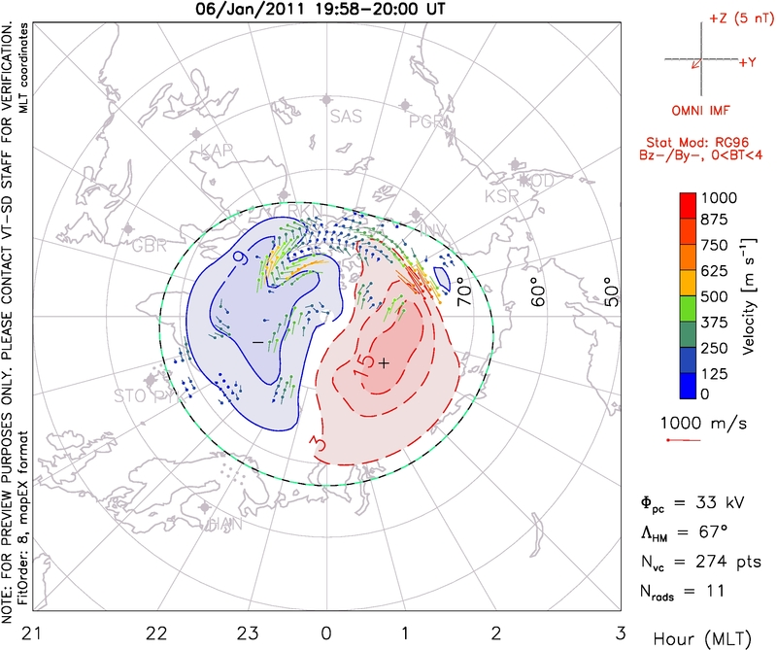
The potential is essencially the same, as well as the velocities, in average, but, the equipotential lines pattern change again, with the polar cap still at the same size. From the magnetometer data, in this time interval, the magnetic field increased, to intervals of 20nT, which might have influenced the ExB drift, so the pattern is more similar to the first one, at 1800.
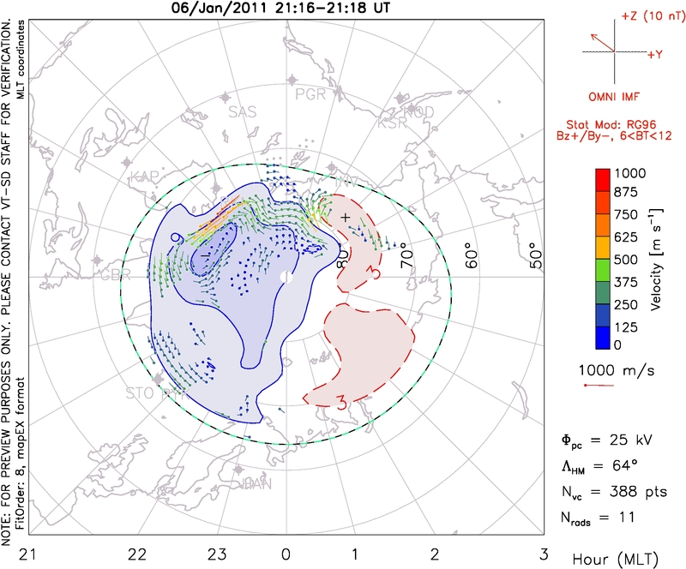

The pattern is very similar to the previous hour at 2100, and some minutes after that, but, by the time that was predicted to solar wind to reach the magnetopause, the equipotential lines change drastically, where the two cell pattern is not so visible, and this holds until 2130, where the pattern returns to something similar to the previous ones. But, we notice that the potential is the lowest, 25kV, but also the polar cap increase a bit.

However around 2145, the polar cap increases even more and so the potential, reaching 51kV. At 2155, we see the polar cap size and the high potential, and also the convection velocity of at least 500 m/s in average
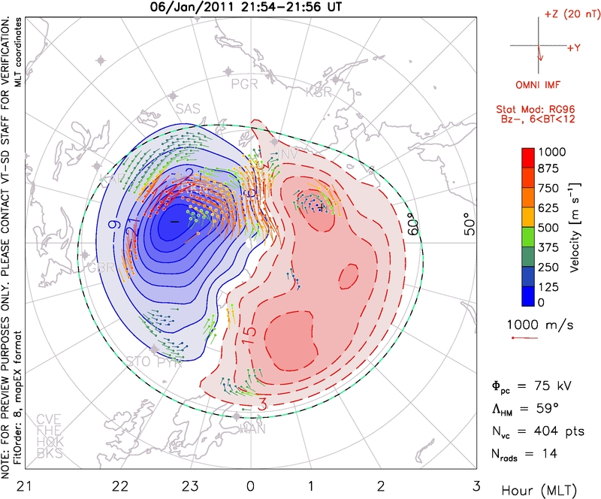

Discussion: By investigating information about the magnetic field on Earth, as well as the generated currents and the plasma convection, it was possible to study the magnetic reconnection phenomena, where the IMF lines connect to the Earths B-lines; the result of this in our planet is the Dungey cycle which is possible because of reconnection.

This way, we described briefly what should happen with these fields and currents, before and after reconnection, and see if the data corresponds to what was predict. These changes allow us to see when reconnection happens and in what circusntances, and one the consequences is the auroral activity, in our case in the North pole. We made an connection between the time the IMF hits the magnetopause, and subsequently reconnection, to the formation of aurora, by the data on All-Sky Camera, which shows more clearly when the substorm sequence starts to happen and when approximately the aurora starts, varying in latitude.

